BALLYMAHON MUNICIPAL DISTRICT

Corporate Affairs,
Aras an Chontae,
LONGFOIRT.

16th June 2016.

To: Each Member of the Ballymahon Municipal District.

A Chomhairleoir,

You are requested to attend the Annual Meeting of the Ballymahon Municipal District to be held in Ballymahon Community Library, on Thursday, 23rd June 2016 at 4.00 p.m. to transact business, as set out on the Agenda hereunder.

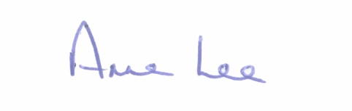
Mise le meas,

_______________
Anne Lee,
Meetings Administrator.

C L A R

1. Election of Cathaoirleach.

2. Election of Leas Cathaoirleach .

3. Fix date and time of Ballymahon Municipal District meetings.

